Date:
Exp: no: 02
Preparing a temporary mount of onion cells
Aim:-To prepare a temporary mount of onion cells and to record observations and draw labelled diagrams.
Materials Required:-
Onion Knife, Forceps ,Blade, Slides, Watch glass, cover slip, brush,
compound microscope, blotting paper, a clean piece of cloth,
Iodine solution, Safranine, Glycerine and water.
Procedure:-
(1)Take a piece of onion scale and bend it towards the concave side until it breaks into two. When it breaks, you will notice that a thin membranous structure still connecting the two bits. This membranous structure is called onion peel or epidermis.
(2)Carefully tear off one of the bits from the epidermis
hold the freed epidermis with a forceps and peel it from the other bit.
(3)take some water in a watch glass and put the epidermis in it. Make certain that it is not folded or rolled.
(4)Add 1-2 drops of Iodine solution or Safranine solution.
(5)After about 2-3 minutes take the peel.
(6)Take a clean glass slide and put a drop of glycerine almost in the middle of the slide.
(7)Place the stained piece of the peel in the glycerine and put a cover slip on it.
(8)Soak the overflowing fluid from the corners of the cover slip with the help of the blotting paper and clean the slide.
(9)Observe the wet mount under the low power of the microscope (10x) and then under high power.
(10)Draw the diagram of the peel as seen under Low power. Then focus the cell under high power (45x) and draw their diagram and compare your diagram.
Observations:-
(a) Under Low power of the microscope
1.The rectangular cells of onion epidermis are seen. The regularly arranged components like cells have clear outline. In this case, the outlines are formed by rigid walls known as Cell Wall.
2. A deeply coloured, round body is seen in side every cell. This is known as Nucleus.
(b)Under the high power of Microscope
1. Nucleus is clearly visible.
2.A thin layer of less deeply coloured substance along the inner surface of cell wall is seen. It is called Cytoplasm.
3. The central part of the cell, interior to the cytoplasm takes very little stain, this portion is known as vacuole.
Inference:
As seen under low and high power of the microscope, the epidermis (peel) of onion scale leaves is composed of cells. Each cell contains cell wall, enclosing the cytoplasm; Vacuole and the Nucleus are found embedded in the Cytoplasm.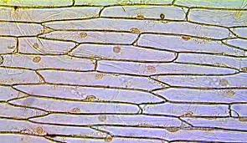 under low power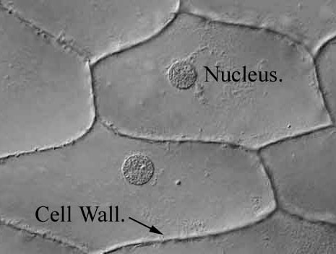under high power

