Artic animal:- POLAR BEAR
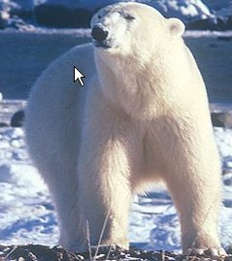
1. Long, stiff hair between pads of bear's feet:
- Protect bear's feet from the cold
- Provides traction on the ice
- Help the bear swim in cold, icy water
- Also helps to keep bear from slipping on the slippery ice
- Hair usually shakes free any water or ice formed after swimming

2. Small and rounded ears
- Prevents water from entering the bear's ears and freezing their
Eardrums
- Helps conserve body warmth in sub-zero temperatures

3. Polar bears have very wide and large paws.
-The wide, large paws help a polar bear to walk on snow.
- Polar bears have sharp claws on their hairy feet. The fur even covers the soles of their feet, providing insulation. These sharp claws allow polar bears to easily kill their prey and then to rip it apart into small chunks to eat.

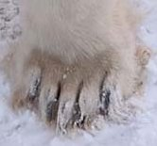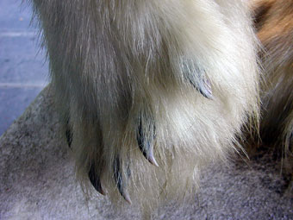

4. Light colour of bear's fur (white) provides camouflage against the ice
- When hunting, bear covers black nose with its paws to hide it

5. Strong swimmers
- Polar bears can travel up to a speed of 10 kph
- Have been known to swim continuously for 100 km
- Enables them to catch prey

6. Thick layer of fat (blubber) under skin
- Up to 11 cm thick
- Insulates bear from arctic cold
- Polar bear swims to cool down on warm days or after physical
activity

7. Skin under fur is black

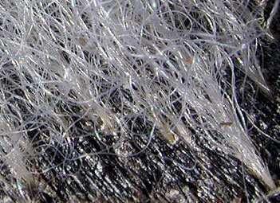

- This is to ensure that the polar bear has a better heat retention
rate. Absorbs the suns heat energy, to keep warm.

Aquatic plant:- Water Lilly

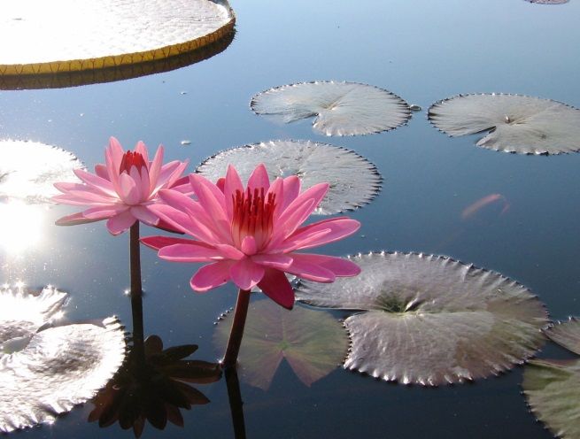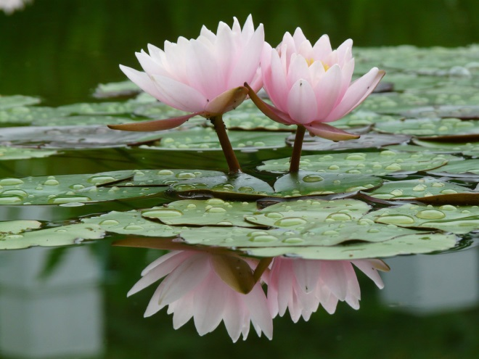

- The most definite adaptation of the water lily is its size. This is because they want to capture as much sunlight as possible.
- Water lilies are rooted, but the roots float, so they can catch sunlight.
- Water lilies also have extremely sharp thorns, so predators do not eat them. T
- hey have air sacs to help with flotation. They also have specialised roots to take in oxygen. Their roots are firmly anchored at the bottom and their stems are unusually long and flexible. This protects them from possible injury from water currents.
- Water lilies face other survival problems as they float on the surface of the water or are held high on their long stems.

Aquatic animals:-
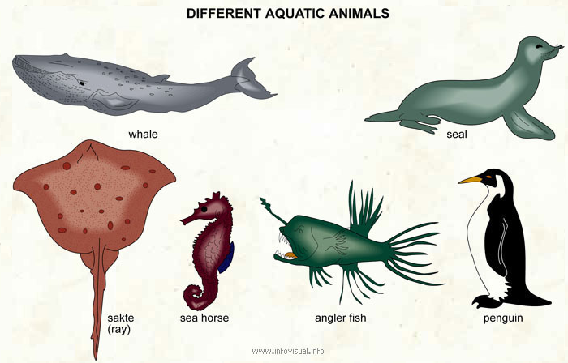
When animals live in the water, they must have special adaptations to help them survive in an aquatic habitat. The more time an animal spends in the water, the more adaptations the animal will have for an aquatic life. Below are examples of some of these adaptations:

1. Streamlined body reduces friction when the animal moves through the water.
2. Smooth, almost furless body helps aquatic mammals move through the water with little friction.
3. Dense fur helps streamline the bodies of some aquatic mammals and keeps them warm.
4. Dense waterproof feathers keep cold water away from bird's skin and prevent wetting of the feathers.
5. Webbed feet, formed from thin skin between the toes, work like paddles.
6. Long legs and necks keep the bodies of wading birds out of the water and are thin, light, and easy to move, and the long neck helps the birds to reach the water, or below it, for food.
7. Strainers in the mouth filter food particles from the water.
8. Flippers provide a large surface for pushing against water and act like paddles.
9. Eyes positioned on top of the head allow animals to hide almost fully submerged in water and still detect predators or prey above the water.
10. Nostrils positioned near the top of the head allow animals to come to the surface to breathe while only a small part of the body can be seen.
11. Nostrils close when the animal goes under the water.
12. Blubber, a thick layer of fat or oil stored between the skin and muscles of the body, provides insulation.
13. Transparent eyelids cover the eyes of animals swimming underwater.
14. Flattened tails serve as paddles.

Desert Animal- Camel
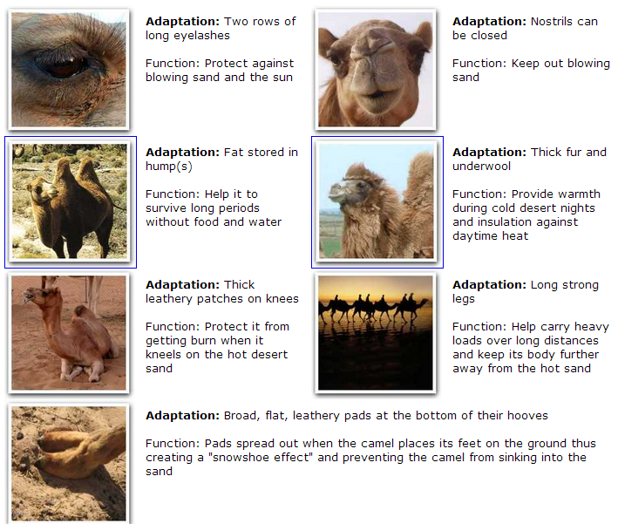

Desert Plants
- Some plants, called succulents, store water in their stems or leaves;
- Some plants have no leaves or small seasonal leaves that only grow after it rains. The lack of leaves helps reduce water loss during photosynthesis. Leafless plants conduct photosynthesis in their green stems.
- Long root systems spread out wide or go deep into the ground to absorb water;
- Leaves with hair help shade the plant, reducing water loss. Other plants have leaves that turn throughout the day to expose a minimum surface area to the heat.
- Spines to discourage animals from eating plants for water;
- Waxy coating on stems and leaves help reduce water loss.
- Flowers that open at night lure pollinators who are more likely to be active during the cooler night.
- Slower growing requires less energy. The plants don't have to make as much food and therefore do not lose as much water.
