Half Yearly Revision- Energy Resources.
- During photosynthesis, green plants trap the _____ energy from the Sun.

- Refer to the classification table below. Fill in each box with the correct form of energy.
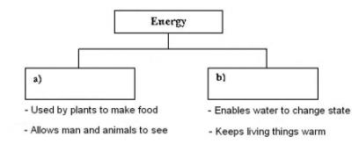

- David burnt some firewood to make a campfire.
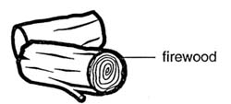
a) Name the 2 forms of energy that he will get when the firewood is burning.

Ans:________________________________________________________________

- List out the advantages and disadvantages of
- Wind energy
- Solar energy
- Biomass
- Hydro
- Geothermal
- What are the three types of fossil fuels? Explain each in a few points
- What are the energy conversions seen when energy from wind is captured by a wind mill?
- What Is meant by renewable and non renewable energy?
- List out various forms of energy. What is meant by potential and kinetic energy?
- Define Energy

