- What is the difference between breathing and respiration?

- What is the ultimate goal of respiration? What two things are needed to achieve this goal?

- Label the given structure of the heart.
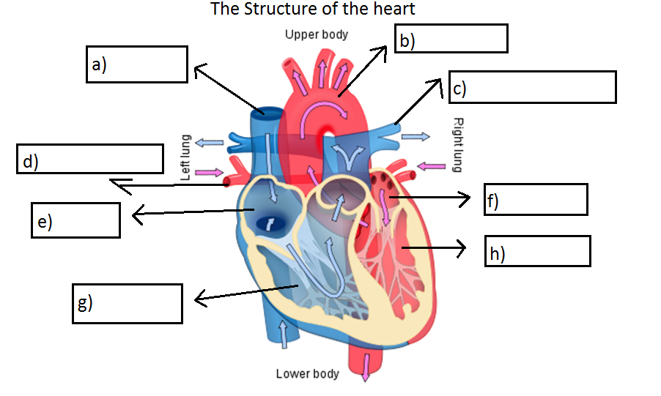
- Which two blood vessels in the diagram carry oxygenated blood?

- In which blood vessel is the blood under the greatest pressure?

- Explain why the walls of the capillaries need to be very thin.

- Which word equation represents anaerobic respiration in muscles?

- glucose → lactic acid + energy
- glucose → ethanol + carbon dioxide + energy
- glucose + oxygen → carbon dioxide + water + energy
- glucose + oxygen → lactic acid + water + energy

- In the form of a flow chart explain the mechanics of breathing.

- Why is yeast used in bread making?
- to provide alcohol
- to provide carbon dioxide
- to provide oxygen
- to provide lactic acid

- Where in the body does respiration happen

- What is the difference between combustion and respiration?

