Potato Osmoscope
Aim: Demonstration of osmosis in living plant cells (by potato osmoscope)
Materials required: potato tuber,knife,10%sugaar solution, saffranine, distilled water, petri dish, pins.
Procedure:
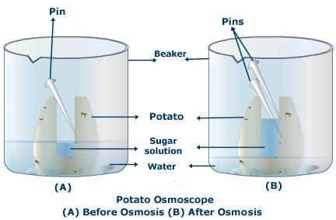
peel off the skin of a potato of medium or large size. Make a cavity in it with the help of knife.
Clean a large petridish and fill it with water .Add 2 or 3 drops of red colour (red ink) or safranin so that water of the dish becomes coloured.
Fill the cavity of the tuber with 10% sugar solution and keep it in the dish, containing coloured water.
Insert a pin on the wall of the cavity in the potato to mark the original level of the sugar solution in it.
Leave the set up for 1 hour.
Observation: After an hour note the increase in the level of the sugar solution inside the cavity of the potato osmoscope. The sugar solution also becomes coloured. Read the new level of sugar solution.
Result: The experiment shows that only the living or semi permeable membrane is responsible for exerting an influence on incoming and outgoing of substances.

Interpretation:
- The potato cavity is surrounded by living cells
- The plasma membrane of each cell inside cell wall acts as a semi permeable membrane.When potato osmoscope is placed in water in the dish, water diffuses into it through cell wall of the potato tuber cells. This is the phenomenon of endosmosis; that is water from the petridish diffuses from its higher concentration to lower concentration. Hence the initial level of sugar solution is increased. This process of endosmosis continues until equilibrium is reached.

