- What are the functions of each these systems:
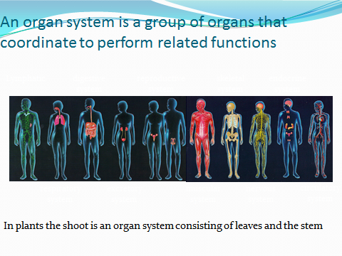
- What are the functions of the various parts in the digestive system.

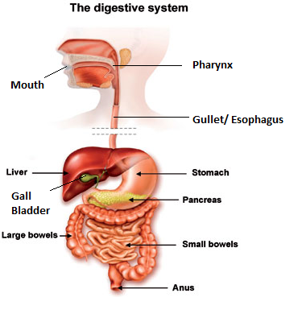
- How will you test for the presence of Carbohydrates, Fats and Proteins?
- What is the main role of the various macro nutrients?
- Name a few micro nutrients
- What is meant by a balanced diet?
- Name the deficiency disease and symptoms of Vit C, Vit D, Iodine, Calcium, Iron.
- Explain the structure of Villi.
- What is difference between excretion and egestion?
- Cross and self-pollination
- Label the structure of the flower
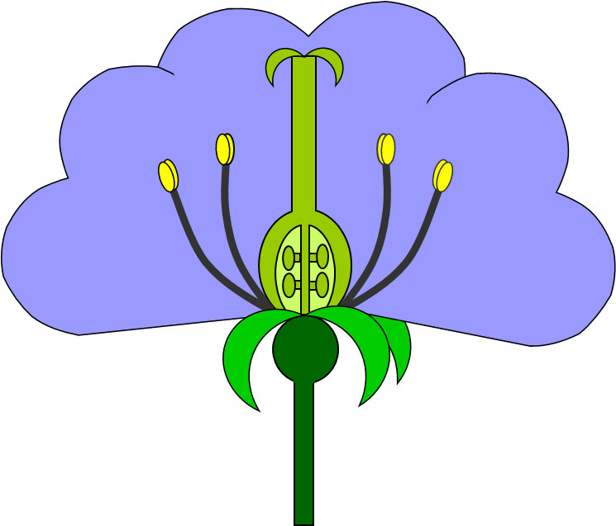

- What is meant by Gamete? What are the gametes found in a plant?
- What is the difference between wind pollinated and insect pollinated flower?
- What is the difference between pre and post fertilization?
- What is the difference between true and false fruits?
- What is the difference between sexual and asexual reproduction ?

