The Neuron
Label the below structure of Neuron, using appropriate terms.
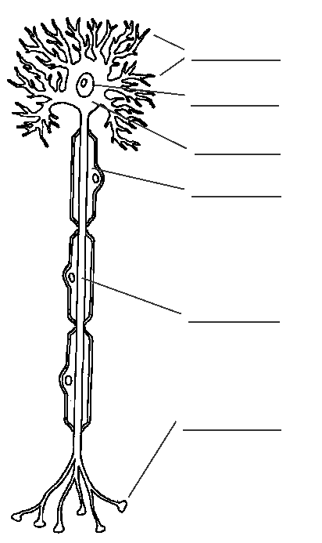

Below is a list of different parts of a neuron. On the lines following each word, write out what that structure does for the neuron (its function) and where it is located on the neuron.
Axon:_________________________________________________________________
___________________________________________________________
Cell Body:____________________________________________________________
___________________________________________________________
Dendrites:____________________________________________________________
___________________________________________________________
Myelin:_______________________________________________________________
___________________________________________________________
Nucleus:______________________________________________________________
___________________________________________________________
Axon/ Synaptic Terminal:____________________________________________________
___________________________________________________________

Read Pg. 89 and 91 from your text book and answer questions 1,2 and 7 on page 93.

