Ganong's Potometer
Aim: to study the process of transpiration using Ganong’s photometer.
Principle: A potometer (from Greek ποτό = drink, and μέτρο = measure) —sometimes known as a transpirometer— is a device used for measuring the rate of water uptake of a leafy shoot. The causes of water uptake are photosynthesis and transpiration. Potometers are often difficult to set up, as measurement-altering air bubbles in the xylem of the plant or in the apparatus must be eliminated. Everything must be completely water tight so that no leakage of water occurs.
There are two main types of potometers used - the bubble potometer (as detailed below), and the mass potometer. The mass potometer consists of a plant with its root submerged in a beaker. This beaker is then placed on a digital balance; readings can be made to determine the amount of water lost by the plant. The mass potometer measures the water lost through transpiration of the plant and not the water taken up by the plant.

Design

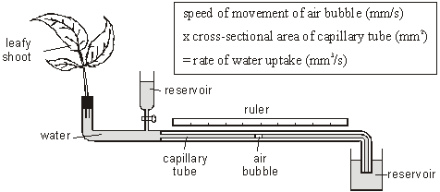

Potometers come in a variety of designs, but all follow the same basic principle.
- A length of capillary tube A bubble is introduced to the capillary; as water is taken up by the plant, the bubble moves. By marking regular gradations on the tube, it is possible to measure water uptake.
- A reservoir. Typically a funnel with a tap; turning the tap on the reservoir resets the bubble. Some designs use a syringe instead.
- A tube for holding the shoot. The shoot must be held in contact with the water; additionally, the surface of the water should not be exposed to the air. Otherwise, evaporation will interfere with measurements. A rubber bung greased with petroleum jelly suffices.

Preparation
- Cut a leafy shoot from a plant and plunge its base into water. This prevents the xylem from taking up any air. Wetting the leaves themselves will alter the rate of transpiration.
- Immerse the whole of the potometer into the sink. Move it about until all the air bubbles come out.
- Recut the shoot's stem underwater. Put it into the bung; grease the bung with plenty of petroleum jelly (Vaseline) if it doesn't stay and then put the bung into the potometer.
- Make sure the tap is closed, then lift the whole assembly out of the water.
- Leave the end of the capillary tube out of the water until an air bubble forms then put the end into a beaker of water.

Use
- Set up the conditions of the experiment. Alterations to lighting (placing the plant in bright light or shadow), wind (directing a fan at the plant), and humidity (placing the plant in a humid chamber) are typical.
- Let the bubble reach a "zero" point in the tube.
- Measure the movement of the bubble at regular intervals and record the results.

Precautions
- When you cut a twig from a plant immediately put it under water (only the cut portion). And then cut a small part under water. This prevents entry of air into the xylem vessels
- Never change the conditions of the potometer during a test as outside conditions determine water uptake.

