WORKSHEET on Structure of the Heart and blood vessels.

- Label the diagram of the heart below.
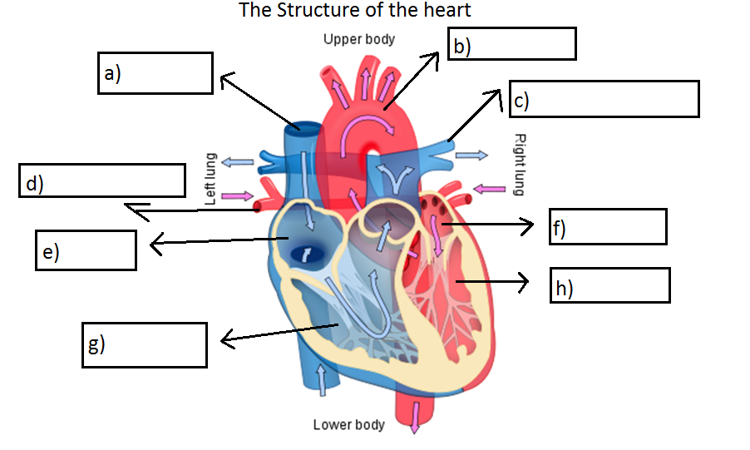
- Which two blood vessels in the diagram carry oxygenated blood?
- In which blood vessel is the blood under the greatest pressure?
- Explain why the walls of the capillaries need to be very thin.
- What word describes how substances pass into and out of the blood.
- Complete the table below
Arteries | Capillaries | Veins
Carry blood -------from the heart | Connect------and -------- | Carry blood------the heart
Have a ------wall | Walls are very ------- | Have a --------wall
Blood flows through at--------- pressure | Low pressure allows exchange of materials | Blood flows through at -----pressure
No------ | No--------- | Valves stop backflow of blood

Worksheet on Gas exchange
- What are the four characteristics the alveoli are designed with for gas exchange?
- By what process do gases pass into and out of your blood?
- From the table below,
- Which gas is produced?
- Why do we breathe out less oxygen than we take in?
- What does the above chart tell you about the body’s use of nitrogen?
Gas | Air we breathe in | Air we breathe out
Oxygen | 21% | 16%
Carbon Dioxide | 0.04% | 4%
Nitrogen | 79% | 79%
Water Vapour | Varies | Saturated

- The diagram shows an alveolus (air sac) and a blood capillary in the lung.
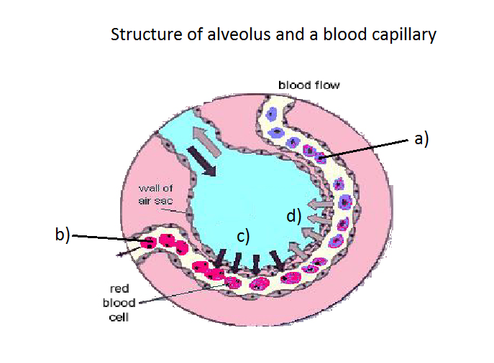
Which letter shows
i)blood high in oxygen
ii)blood low in oxygen
iii)the diffusion of oxygen
iv)the diffusion of carbon dioxide?
- What do you understand by the term double circulation?

