Date:

Exp: No: 10

**Identify 4 adaptations they show to survive in their environment.**

1. cactus

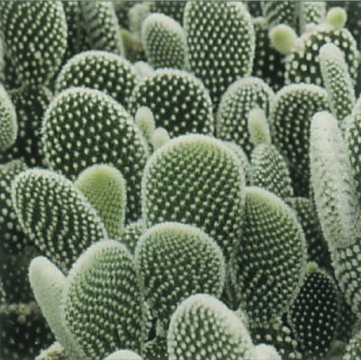

2. camel

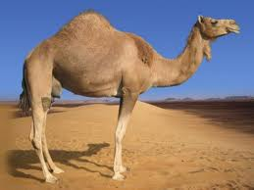

3. Water lilly



What is represented in the following images? write 2 points about them.

4. Pyramid of numbers

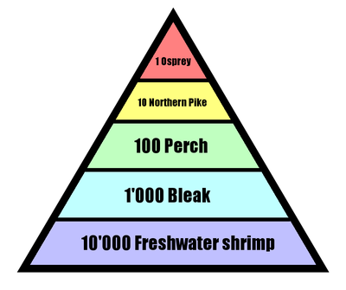

5.

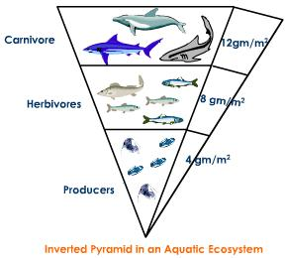

6. Food web

