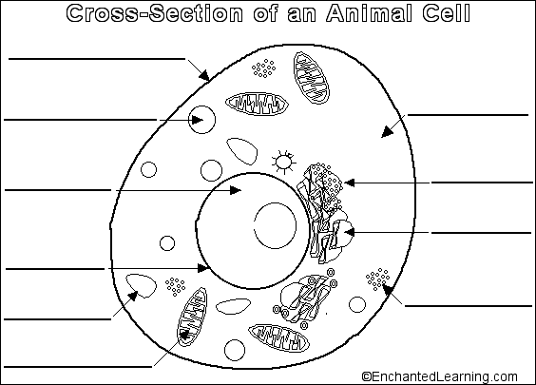

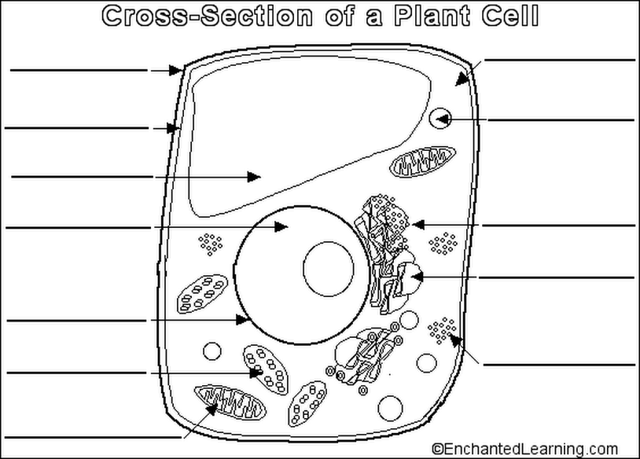

**Unit: Cells**

**POP QUIZ**

**Name: Date:**

**Time Alloted: (30mins)**

**Answer all questions in the space provided.**

1. State the following structures as organelle, cells , tissues or organs (0.5 mark each)
2. Ovum b) heart c) muscle d) neuron e) mitochondrion f) xylem g) stomach h) brain

Ans1) a-

b-

c-

d-

e-

f-

g-

h-

1. How is the function of mitochondria, ribosome and chloroplast different from each other? (1M)

Ans2)

1. What are amoeba, paramecium and euglena called as? (1M)

Ans3)

1. The diagram shows a palisade cell from a leaf. Which labeled structure produces oxygen?(1M)



Ans 4)

1. To enter or leave a cell, substances must pass through (1M)

* a microtubule.
* the Golgi apparatus.
* a ribosome.
* the nucleus.
* the plasma membrane.

1. Which of the following correctly matches an organelle with its function?(1M)

* a. mitochondrion . . . photosynthesis
* b. nucleus . . . cellular respiration
* c. ribosome . . . manufacture of lipids
* d. lysosome . . . movement
* e. central vacuole . . . storage

1. Name this structure 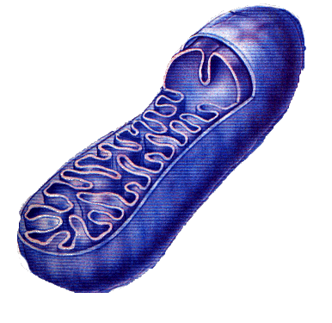 (1M)
2. Name this structure 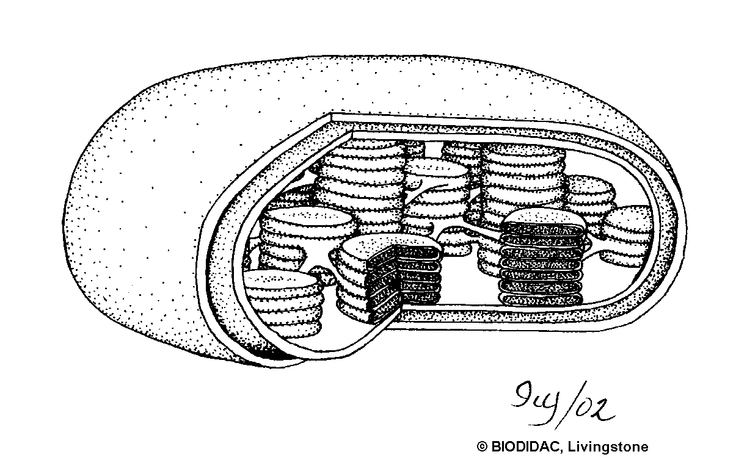 (1M)

Ans8)

1. State four difference between a plant and an animal cell (2M)

Ans9)

1. State the cell theory. (2M)