Date:

Exp:No: 09

ALCOHOLIC FERMENTATION IN YEAST

Aim: To Demonstrate Alcoholic Fermentation in Yeast

Principle: Respiration is a process in which the cells breakdown (oxidize) the glucose to yield energy rich ATP molecules releasing CO2. If oxygen is used during respiration the process is called as aerobic respiration and if oxygen is not used the process is known as anaerobic respiration. Yeast cells can use oxygen if it is present and in the absence of oxygen yeast will switch to anaerobic respiration. The end products of anaerobic respiration are CO2 and ethanol. Anaerobic respiration of yeast is also known as alcoholic fermentation process. Aerobic respiration yields a more energy per sugar molecule than anaerobic respiration.

Materials required: Bend tube, 2 test tubes, glucose solution, oil, lime water, yeast suspension

Procedure:
- Take a test tube and add about 10 ml of 10% glucose solution in it.
- Add a pinch of dry baker's yeast into the glucose solution
- cover the surface of the liquid carefully with an oily layer to prevent the contact with air.
- Fix a holed cork into the mouth of the test tube and pass a delivery tube through it.
- The other end of the delivery tube is dipped in lime water.
- The whole apparatus is made air tight.
- The test tube with glucose is kept in warm water (37ºC - 40ºC) in a beaker.

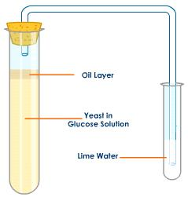
Experimental Setup to Show Alcoholic Fermentation in Yeast
Observation:
It is observed that after sometime, air bubbles arise and they turn the lime water milky
Inference:
The air evolved is carbon dioxide. on opening the cork of the test tube containing sugar and yeast the smell of alcohol is observed. This shows that the products of anaerobic respiration by yeast are ethyl alcohol and carbon dioxide

