Worksheet on Unit 6 – Ecology

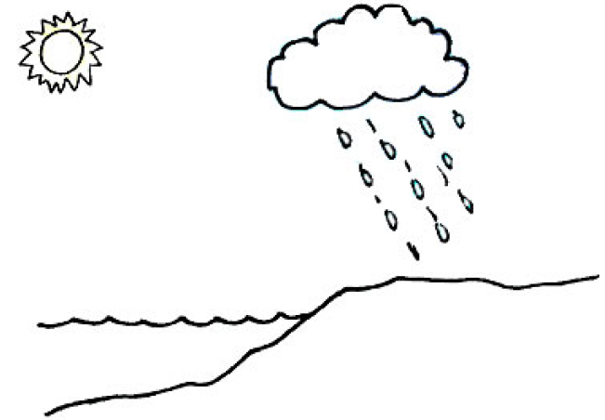
a. Draw and label where evaporation would happen.
b. Label where precipitation is seen.
c. Label where you would find water vapour.
d. Evaporation rises or falls? ______________________________________
e. Precipitation rises or falls? _____________________________________

2. What is the process by which plants convert carbon dioxide into energy-rich carbon compounds?
3. Explain what can happen over millions of years to the carbon compounds in organisms that die and decompose.
4. How do plants and animals help to maintain a balance of carbon dioxide in the atmosphere?
5. There are 12 words that are mentioned when talking about the water cycle. Identify all 12 words from the table below.
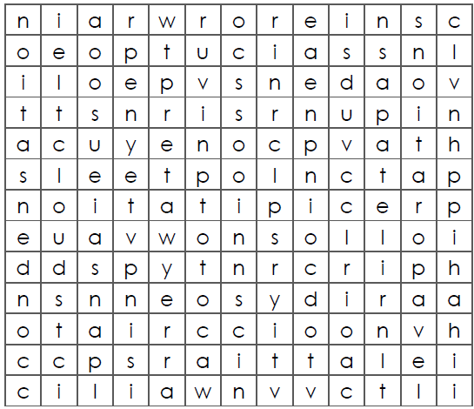

6. Note down all the adaptations of the two organisms showcased in the picture below.
