Revision questions on the Unit Cells and Chemistry of life.

- What is meant by Hierarchical structural organization? State the various organ system present in the human body (View slide No 56 in Cell ppt)

- Label a plant and animal cell.
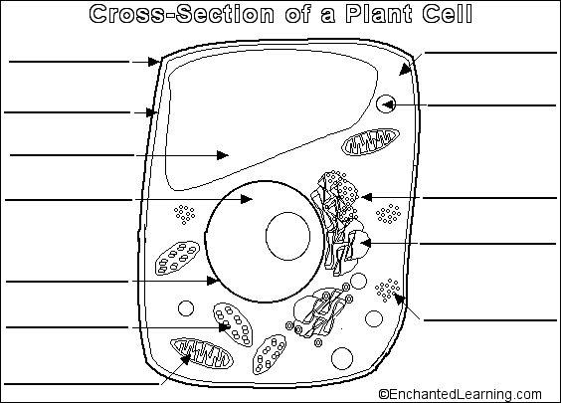
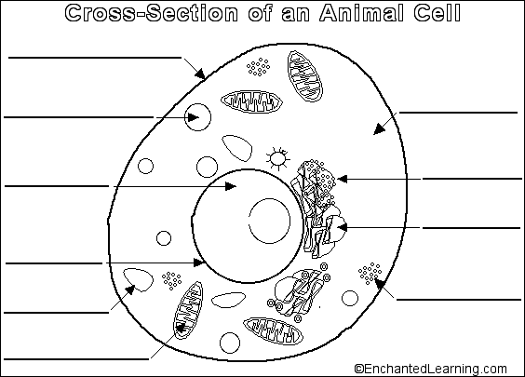

- State the functions of Nucleus, mitochondria, cell membrane, cell wall, lysosomes, RER and SER.
- What is meant by genetic code? Where can it be found? What is the other name for Genetic code?
- Name the deficiency diseases of all the vitamins learnt.
- What are the differences between a plant and animal cell?
- What do you understand by the term specialized cell? With an example write down its modifications and the reasons for it.
- Which enzyme breaks down maltose to give fructose?

