Simple chemical reactions
- Minah was given a container with Substance X in it.
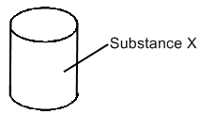
In addition, she was given three other empty containers Q, R and S and a syringe.
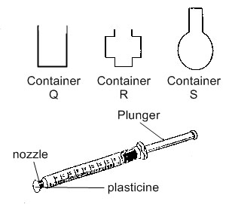
(a) How could she show that substance X has no definite shape?
_________________________________________________________________________

_________________________________________________________________________
(b) How could she show that substance X has no definite volume?
_________________________________________________________________________

- Complete the following classification diagram using the words in the box.

solid | hydrogen | oxygen
liquid | syrup | hair

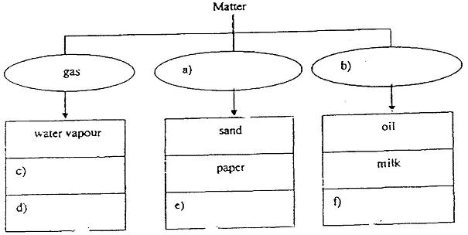

- An experiment is set up as shown below. A needle is then pricked into balloon B, bursting it.

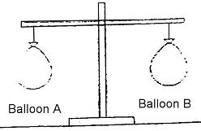
a) What will you observe about the balance?
______________________________________________________

b) What does this experiment show?

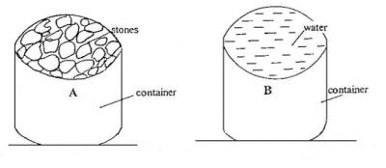
(a) Container A is filled with stones. What are the states of matter in Container A?
__________________________________________________________

(b) Container B is filled with water. When the contents of Container B are poured up to the brim of Container A, what are the states of matter in Container A now?
_________________________________________________________

- Mrs Lee gave Allan two identical deflated balloons, attached with strings of equal length. He filled balloon A with gas X and balloon B with gas Y. Both balloons contained the same amount of gas.

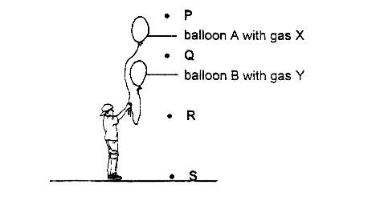
(a) Explain why Balloon A floats at a higher level than Balloon B.

___________________________________________________

___________________________________________________
- A cannot be compressed. However, when it is heated, it will change its state to B. B takes up the shape of the container. Further heating will cause B to change its state to C and C and be compressed.

a) What states do A, B and C represent?

A:_______________

B:_______________

C:_______________

b) What could be done in order to change the sate of B back to A? Explain your answer.

Ans:________________________________________________________________________________

- What is meant by the term Brownian motion and diffusion
- Write the procedure for the pop test
- Why does the lime water turn milky when you blow into it?
- State a few examples under reversible and irreversible changes

