HOMEWORK GRADE 6
Date of Submission: 4th September

Jake decided to make a model of an animal cell. He collected some runny jelly, a small ball and a plastic bag.
- Which parts of the cell do you think each item in Jake’s collection was for?
- What other materials would be better for making a model of an animal cell? Why might these be better?
- What other parts would he need to add to turn the model into a plant cell? What might he use for each of these parts?
- Jane made the following drawings of cheek cells and onion skin cells during a science lesson. However, she forgot to give each drawing a title.
(1) Please help Jane identify the cells she drew by writing 'cheek cells' and 'onion skin cells' in the spaces provided below each drawing.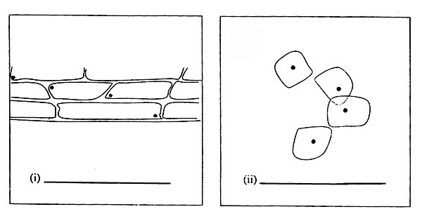

(b) Explain how you were able to identify the 2 different types of cells from Jane's drawings.

