- What are the food sources for fats, proteins, vitamin A and C
- What are the functions of each of the nutrients?
- What is meant by a balanced diet?
- Label the digestive system. Name the parts in order present in an alimentary canal.
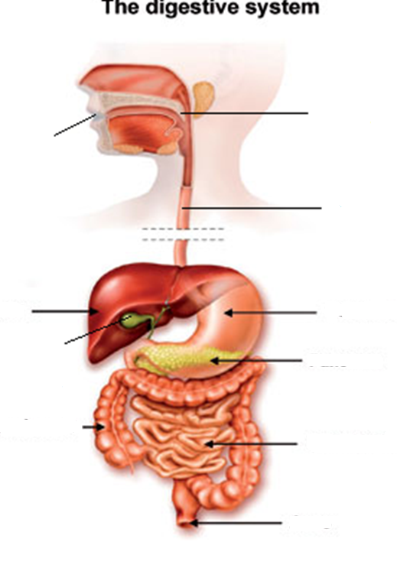
- What is the function of the accessory digestive organs?
- What happens to the digested food in the small intestine?
- Where does the major part of digestion occur in the body? What is another word for esophagus?
- Describe the process of digestion in detail
- What is the function of villi?

