Microscopic Observation of Yeasts Cells

Aim: To observe yeast cells under microscope

Principle: Respiration is a process in which the cells breakdown the glucose to yield energy rich ATP molecules releasing CO2. If oxygen is used during respiration the process is called as aerobic respiration and if oxygen is not used the process is known as anaerobic respiration. Yeast cells can use oxygen if it is present and in the absence of oxygen yeast will switch to anaerobic respiration. The end products of anaerobic respiration are CO2 and ethanol.

Materials required: Beaker, Dropper, Glass stirrer, Dry Baker’s Yeast, Glass slide, Cover slip and microscope

Procedure:
- Take a beaker and add a pinch of Baker’s yeast.
- Add water and mix it well using glass stirrer.
- Take a drop of the solution using a dropper and place it onto a clean glass slide.
- Cover the drop of solution with a cover slip.
- Observe it under microscope and record it.

Observation:
Round shaped cells are observed under microscope.

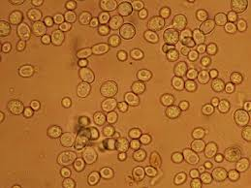Diagram to be drawn on the left hand side.

Conclusion:
The yeasts cells were observed under microscope.

