Plasmolysis
Aim: to study the effect of plasmolysis in the epidermal cells of Rheo discolor.
Prior knowledge: Use of the microscope, plant cell structure, the principles of osmosis, the meaning of 'epidermis' and 'cortex'.

Advance preparation

Rheo discolor leaves Use freshly cut Rheo discolor with bright red epidermis.

Sucrose solution. Prepare 5% solution by dissolving 5 g sucrose in 100 cm³ tap-water.

Blotting paper. Cut strips of blotting paper or filter paper approximately 20 x 60 mm. Allow
4 strips per group.

Apparatus-per group

scalpel or razor blade
fine forceps
microscope slide
cover slip
microscope with x 100 magnification
dropping pipette
container for sucrose solution
container for water
4 strips of blotting paper
Procedure:

(a) Use a scalpel or razor blade to make a shallow transverse cut in the red epidermis of the piece of
Rheo discolor stalk.

(b) With a pair of fine forceps lift up a strip of the epidermis at one side of the cut. Lift only the
epidermis and not the underlying cortex. Having freed a narrow band of epidermis, pull it off with the forceps (Fig. 1) and press it flat on a slide with the outermost surface upwards.

(c) Use the scalpel or razor blade to cut about 10 mm of this strip from the thinnest and reddest
portion (Fig. 2) and, using a dropping pipette, cover this with 3 drops of water.

(d) Use the forceps to lower a cover slip carefully on to the water drops, avoiding trapping air bubbles (Fig. 3), and examine the epidermis under the microscope using the x10 objective.

(e) Move the slide about to find a group of clearly defined cells near the edge, with red cell sap, and make a drawing in your notebook to show one of these cells. Draw the cell at least 50 mm long, representing the outline accurately and shading the area filled with cell sap. Clip the slide
securely to the microscope stage and leave it in this position for the rest of the experiment.

(f) Use the pipette to place 2 drops of sucrose solution on the left-hand side of the slide, just touching the edge of the cover slip.

(g) Draw all this solution under the cover slip by applying a strip of blotting paper to the right- hand edge of the cover slip. Try not to move the slide, the cover slip or the epidermis.

(h) Examine the cells again and watch for about 2 minutes. If nothing happens, draw through some more sucrose solution.

(i) When a significant change has occurred in the cells, draw the same cell as before to show the
cell wall and the cell sap. The cell is plasmolysed.

(j) Use the pipette to place 3 drops of water on the left hand' side of the slide and draw it through under the cover slip as before. Do this twice to flush out all the sucrose solution.

(k) Study the cells again for about 2 minutes repeating operation (j) if nothing happens in this time.

Observation:

Discussion:

1 When the rhubarb cells were exposed to sucrose solution what change did you observe in
(a) the shape of the vacuole and (b) the colour of the cell sap?

2 What change, if any, took place in the shape of the cell?

3 Bearing in mind the fact that liquids cannot be compressed, what must have happened to the cell sap to account for (a) the change in volume and (b) the change in colour?

4 After exposure to the sucrose solution, what do you suppose occupied the space between the
vacuole and the cell wall in the plasmolysed cells?

5 Why did the cell sap not mix with the liquid in this space?

6 Which part of the cell must be 'selectively-permeable' in order to explain these results?

7 How do the results of this experiment lead to the conclusion that the cell wall is permeable not
only to water but also to dissolved sucrose?

8 What effect would it have on the tissues of the whole plant if all the cells were plasmolysed?

9 (a) What changes took place in the cells when the sucrose was replaced by water? (b) How can you explain these changes in terms of osmosis?

10 How would this change, if it applied to all the cells, affect the tissues of the plant as a whole?
cell wall
red cell sap
Fig. 4 Diagram of single cell from the epidermis
nucleus and cytoplasm (not likely to be visible in
your preparation)
Fig. 3
Fig. 2
Fig. 1
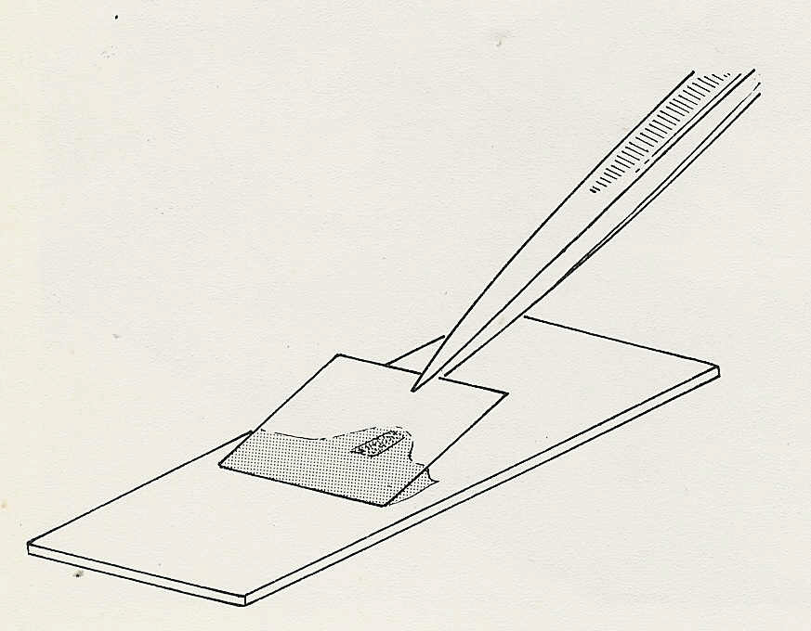
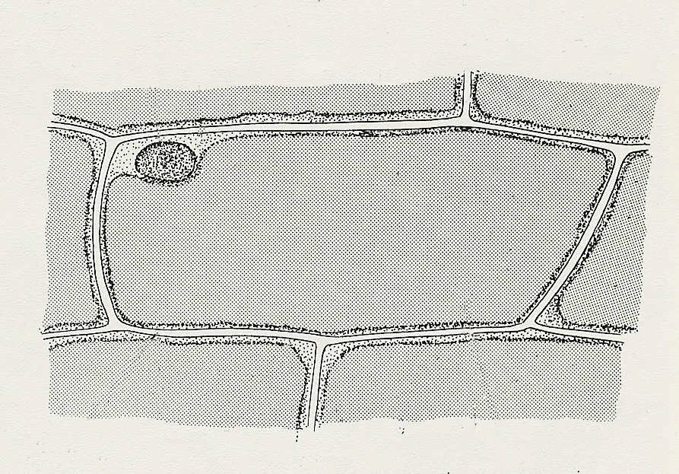
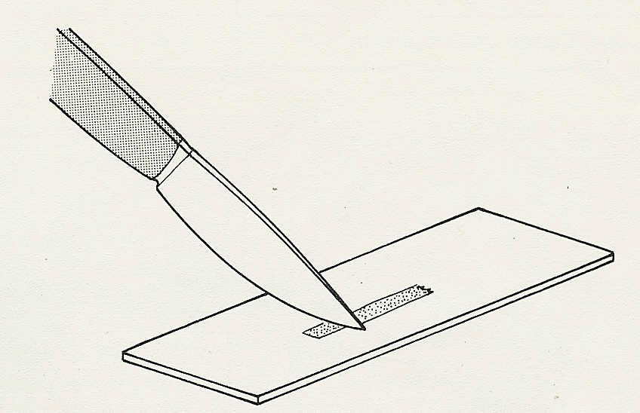
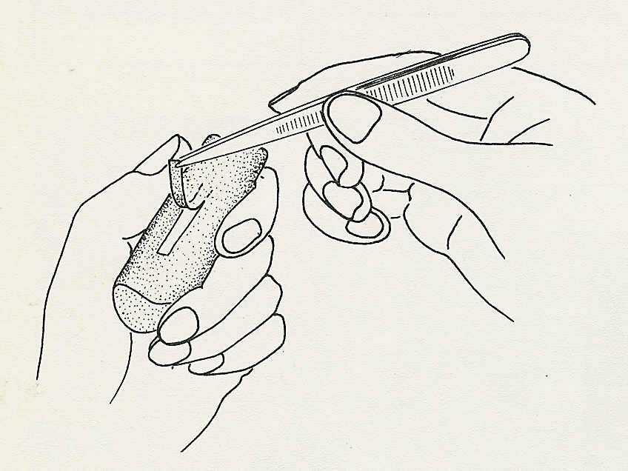
Experiment 8. Discussion - answers

1 (a) The vacuole should diminish and appear to separate from the cell wall in places.
(b) The cell sap may become noticeably deeper in colour when compared with unplasmolysed
cells.

2 There should be no perceptible change in the shape of the cell.

3 The cell sap must have lost part of its contents, presumably water. This would account for its diminution in volume and, since the red pigment would become more concentrated, the intensification of its colour.

4 The space between the vacuole and cell wall must be occupied by the sucrose solution (and, of
course, the cell membrane and cytoplasm bounding the cell sap).

5 The cell membrane, tonoplast and cytoplasm separate the solution and the cell sap.

6 The cell membrane, the cytoplasm, the tonoplast or some combination of these must be selectively permeable.

7 If the cell wall were selectively permeable, the loss of water to the sucrose solution would distort the cell wall and no space would appear between it and the vacuole.

8 If all the cells in a plant were plasmolysed, the unsupported structures would be limp and wilting and the plant would eventually die.

9 (a) When the sucrose solution was replaced by water, the cells recovered from the plasmolysed
condition and the vacuole expanded to fill the cell once again.
(b) The cell sap now contains a stronger solution than the surrounding fluid and absorbs water - through the selectively permeable cytoplasm.

10 A plant with its cells turgid would have firm tissues, an erect stem and expanded leaves.

Inference/Conclusion:

