Completed worksheet for the activity
1. Energy that is stored within an object is called ____potential____ energy.
2. The vibration and movements of the atoms and molecules within substances is called heat
or ____thermal____ energy.
3. The energy stored in the centre of atoms is called ____nuclear____ energy.
4. The movements of atoms, molecules, waves and electrons is ____Kinetic____ energy.
5. The movement of electrons is ____electric____ energy.
6. The energy in petroleum and coal is stored as ____chemical____ energy.
7. A hydropower reservoir is example ____gravitational____ energy.

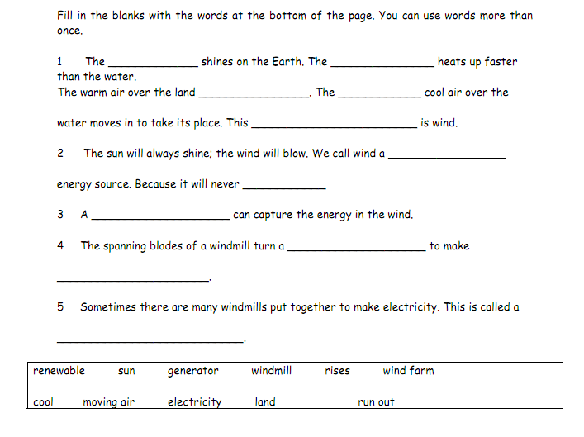

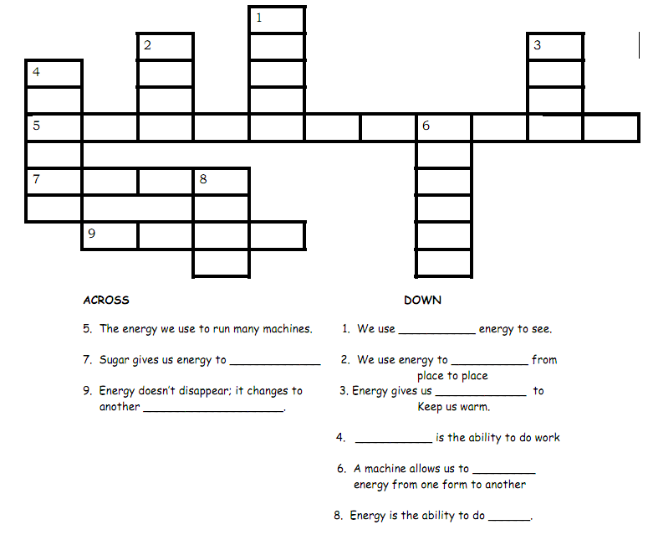
Complete these sentences using the most suitable word:
a) Coal, natural gas and oil are all _________________ (renewable / non-renewable) energy resources. They release _______________ (energy / electricity) when they are burned.
b) Wind and solar energy are _______________ (renewable / non-renewable) because they _______ (can / cannot) be replaced.
c) Coal, natural gas and oil are called ________________ (nuclear fuels / fossil fuels).
d) Two more examples of renewable energies are _________________ and _________________.

