WORKSHEET FOR STOMATA
1)Draw and label the below structure.
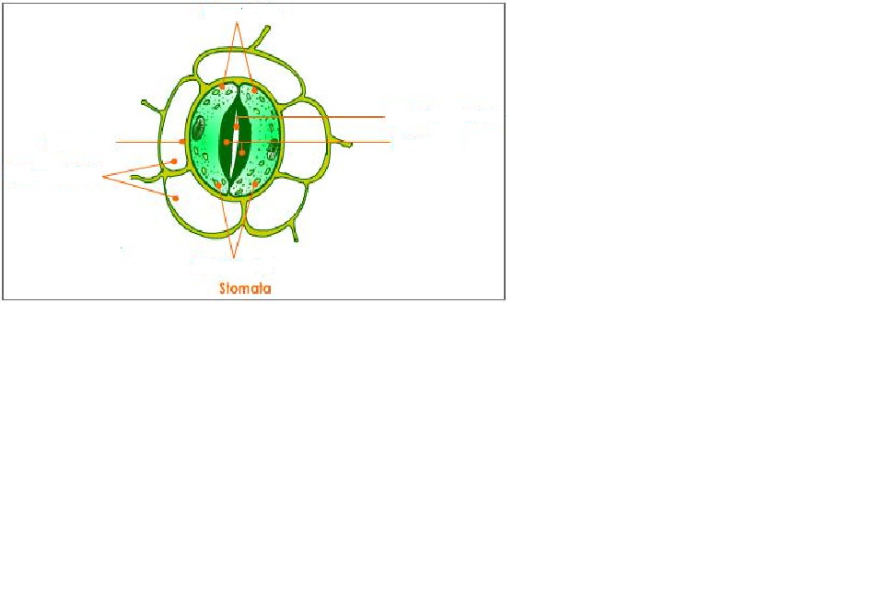2) Look at the diagram below which shows an enlarged part of a leaf.
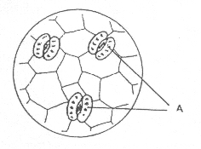
(a) What are the tiny openings labelled A called?

(b) State one function of the part labelled A.

3) The diagram shows a plant and the stomata found on the underside of a leaf.

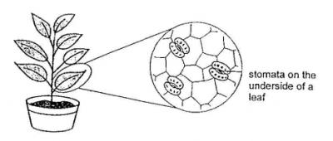

(b) William wants to find out what will happen to the leaf if there are no stomata. His friends offered some ways to help him achieve his objective.

Tina: You can apply oil to the upper side of the leaf.
Joe: No, you need to apply oil to the underside of the leaf.
Kenny: I think you need to apply oil on both sides of the leaf.

Whose suggestion is the best and why?

4) Why would it be useful for there to be a large number of chloroplasts in the guard cells?
5) Under what conditions does the size of a stomatal pore change?

6) Match the plant parts with their functions.
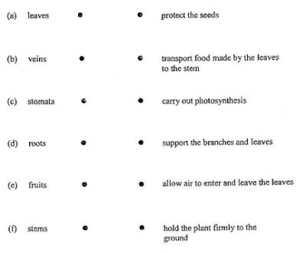

7) Fill in the blanks with the most appropriate words.
(a)
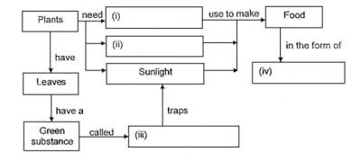

(b) Name the process that is taking place in (a).

